Project Proposal


JOINTSENSE AI
(AI-Powered Automated Assessment and Severity Prediction of Knee Osteoarthritis with Stage-Wise Lifestyle Guidance)

Project By:
M. Noman Kiyani - 221111
Habib Ur Rehman - 221061
M. Muneeb Imran - 221063

Supervisor
Ms. Eeman Fatima

Department of Computer Science
Air University Islamabad

Contents
1. Introduction 2
2. Related System Analysis / Literature Review 2
3. Problem Statement 3
4. Problem Solution / Objectives of the Proposed System 3
5. Scope 3
6. AI-Powered Enhancements and Improvements 4
7. Modules 4
8. System Limitations/Constraints 6
9. Data Gathering Approach 6
10. Tools and Technologies 7
11. Project Stakeholders and Roles 7
12. Module based Work Division 8
13. Gantt chart 9
14. Future Enhancements 9
15. Mockups 10
Conclusion 10

Supervisor Meeting Log:
 | Discussion | Task Assignment | Supervisor Signature
Meeting 01 | New FYP Ideas, Feasibility, Constraints. | Write Initial Proposal
Meeting 02 | Modules to include, Stack selection.

1. Introduction:
Knee arthritis is a growing concern, due to hormonal changes, genetic predisposition, and lifestyle factors. Early prediction is crucial to prevent severe joint damage and improve mobility. However, traditional diagnostic methods rely on physical examinations and imaging techniques, which often lead to delayed treatment.
This project proposes an AI-powered web and mobile-based system for the automated assessment and severity prediction of knee osteoarthritis, providing stage-wise lifestyle guidance. By integrating machine learning models trained on medical imaging and leveraging IoT and mobile sensor data for real-time adherence tracking, the system aims to assist in early prediction, personalized lifestyle recommendations, and monitoring of patient adherence to these recommendations.
2. Related System Analysis / Literature Review:
Several healthcare applications focus on arthritis management, but they lack AI-powered early prediction, real-time patient monitoring, and personalized treatment recommendations. Our system will address these gaps by utilizing machine learning models trained specifically on X-ray images for severity grading and integrating a rule-based recommendation engine informed by medical guidelines.
Comparison with Existing Applications:
Application | Weakness | Proposed Improvement in Our System
Mayo Clinic Arthritis Tool | Provides general arthritis information for educational purpose and symptoms but lacks AI-based personalized insights. | AI-based personalized prediction & early diagnosis for both genders (Note: Prediction and severity grading in current scope).
Arthritis Power App | Focuses on patient-reported data but lacks AI-driven risk assessment | Real-time symptom monitoring & risk prediction based on hormonal changes (Note: Adherence tracking using IoT/mobile sensors in current scope).
Physio Therapy Apps | Offers physiotherapy exercises but does not integrate AI-based medical analysis | AI-powered treatment & exercise recommendations based on patient condition (Note: Focused on rule-based lifestyle guidance and adherence tracking in current scope).

3. Problem Statement:
Both males and females are at risk of developing knee arthritis due to genetic predisposition, obesity, aging, lifestyle factors, and previous joint injuries. Although fragmented solutions address individual components like AI-driven image analysis or mobile health tracking, there is a distinct gap for an integrated AI-based system. Our project uniquely bridges this by focusing on the early prediction of knee osteoarthritis, providing personalized lifestyle guidance, and crucially, incorporating automated, real-time adherence tracking through IoT and mobile sensors for both genders. This creates a proactive, closed-loop feedback system, addressing the limitations of existing reactive approaches that often result in delayed intervention and increased joint damage.

4. Solution & Objectives of the Proposed System:
To address these challenges, this project proposes an AI-powered tool for automated assessment and severity prediction of knee osteoarthritis, providing stage-wise lifestyle guidance. The system will primarily:
- Analyze X-ray images using AI to predict OA status (Binary: OA/No OA) and classify severity based on Kellgren-Lawrence (KL) grades (0-4).
- Generate an automated OA Prediction and Severity grading output, including KL Grade, stage, severity, and a risk score.
- Provide rule-based lifestyle management recommendations driven by sources like American College of Rheumatology (ACR) guidelines and NHS/CDC/WHO arthritis management recommendations.
- Track patient adherence to lifestyle recommendations in real-time using a low-cost, sensor-embedded knee band connected to a mobile application.
- Facilitate the visualization of progress by storing results for future tracking and allowing download of AI outputs.

Objectives:
To address these challenges, this project proposes an AI-powered tool for automated assessment and severity prediction of knee osteoarthritis, providing stage-wise lifestyle guidance. The system will primarily:
- Analyze X-ray images using AI to predict OA status (Binary: OA/No OA) and classify severity based on Kellgren-Lawrence (KL) grades (0-4).
- Generate an automated OA Prediction and Severity grading output, including KL Grade, stage, severity, and a risk score.
- Provide rule-based lifestyle management recommendations driven by sources like American College of Rheumatology (ACR) guidelines and NHS/CDC/WHO arthritis management recommendations.
- Track patient adherence to lifestyle recommendations in real-time using a low-cost, sensor-embedded knee band connected to a mobile application.
- Facilitate the visualization of progress by storing results for future tracking and allowing download of AI outputs.

Scope:
The system will cater to patients and medical professionals, enabling them to:
- Access AI-powered knee osteoarthritis prediction and severity grading based on X-ray imaging.
- Receive AI-driven, rule-based lifestyle recommendations (e.g., daily steps, diet, general health reminders) tailored to their predicted KL grade.
- Track daily activity levels (e.g., joint movement, load) and temperature through the integrated sensor-embedded knee band for real-time adherence monitoring, accessible via the mobile application.
- Monitor predicted disease progression and risk factors to adjust lifestyle plans.
- Enable remote review of AI analysis and tracked patient progress by doctors via web and mobile portals.

6. AI-Powered Enhancements and Improvements:
6.1 AI-Based Image Analysis for Predicction and Severity Grading:
- AI will process X-ray scans to predict OA status (Binary: OA/No OA) and grade severity according to the Kellgren-Lawrence (KL) scale (0-4).
- The model output will include a Grad-CAM heatmap for visual explanation and explanatory text to accompany the prediction.
- Provides risk assessments based on bone density, joint space narrowing, and inflammation (as derived from KL grade analysis).
6.2 Symptom & Lifestyle Monitoring (Automated and Semi-Automated):
Automated Data Tracking via Knee Band: Utilizes a custom sensor-embedded knee band to collect real-time data including:
- Flex Sensor: For joint movement tracking (e.g., knee flexion/extension).
- Load/Pressure Sensor: For load distribution and joint stress.
- Temperature Sensor: To detect inflammation.
- Pulse Sensor: For basic cardiovascular monitoring during activity.
- Automated/Semi-Automated Weight Tracking: Supports integration with Bluetooth weight scale (Optional) or allows users to manually input daily/weekly weight to store & visualize trends.
- Activity Level Monitoring: Leverages the knee band’s sensors to track general activity and movement patterns.
- Diet Tracking (Semi-Automated): Can integrate with free APIs (like MyFitnessPal API, or OpenFoodFacts) or support manual logging, then generate a daily dietary score or reward based output.
- The system compares tracked adherence with AI-generated goals and computes a daily adherence score, creating a closed-loop feedback system.

6.3 AI-Driven Personalized Lifestyle Recommendations (Rule-Based):
- Recommendations for joint health tips, low-impact cardio, weight maintenance, mild pain management, supervised strength training, posture, physical therapy, avoiding joint overuse, dietary adjustments will be generated based on the predicted KL Grade.
- These recommendations will be driven by a rule-based engine referencing established medical guidelines (American College of Rheumatology (ACR) guidelines, NHS/CDC/WHO arthritis management recommendations).
- Custom recommendations will be adjusted based on the patient's predicted KL grade, age, BMI, and tracked activity levels.
6.4 Predictive Analytics for Osteoarthritis Risk Assessment:
- AI forecasts future joint deterioration based on the predicted KL grade and tracked lifestyle factors.
- The system will provide preventive strategies to slow down disease progression, with clear disclaimers that this is an assistive prediction.

7. Modules:
7.1 User Management & Authentication:
- Secure signup/login for patients and medical professionals.
- Profile management with medical history and lifestyle data.
- Role-based access control (patient, doctor, admin).
7.2 AI-Powered Knee Osteoarthritis Prediction & Severity Grading:
- X-ray image analysis using AI.
- AI-generated OA status (Binary: OA/No OA) and KL Grade classification (0-4).
- Output will include a Grad-CAM heatmap and explanatory text.
- Risk assessment based on patient-specific factors.
7.3 IoT & Mobile Sensor-Based Adherence Tracking:
- Automated tracking of daily step counts via Google Fit/HealthKit APIs or BLE smartwatches.
- Automated/manual tracking of weight via Bluetooth scales or user input.
- Tracking of general activity level using mobile sensors knee band sensors.
- Comparison of tracked activity vs recommended range and daily score for adherence.
- (Optional semi-automated) Diet tracking using APIs or Manual logging .

7.4 Personalized Lifestyle Recommendations (Rule-Based):
- Rule-based recommendations for appropriate physical activity (e.g., daily steps range), anti-inflammatory diet sample plans, and general health reminders based on predicted KL Grade.
- Medication reminders & lifestyle change recommendations.
- Adjustment of treatment plans based on patient progress.
7.5 Osteoarthritis Progression Visualization:
- AI analyzes fetched data (predicted KL grades, tracked adherence) to visualize potential disease progression.
- Forecasts arthritis risk and deterioration based on lifestyle factors.
- Generates BMI graph from X-ray day onwards and shows potential impact of weight loss on OA stage projection.
- Preventive recommendations to slow progression
7.6 Doctor & Patient Collaboration (Web-based & Mobile-based):
- Secure messaging & remote consultation portal.
- Doctors can review AI analysis & adjust treatment plans.
- Shared progress reports & medical imaging results.
- Patients can book in-person or virtual sessions.
7.7 Data Visualization & Reports:
- Graphs showing symptom trends & treatment effectiveness.
- AI-generated progress reports for doctors & patients.
- Interactive dashboards for real-time monitoring.
7.8 Community Support & Discussion Forums:
Patients can connect & share experiences with others.
AI moderates discussions & suggests helpful resources.
Doctor-led Q&A sessions on arthritis management.

8. System Limitations/Constraints:
- Data Availability: Limited datasets specific to knee arthritis may impact AI training, though use of OAI or Stanford KneeXray with KL labels is planned. Ethical considerations for real patient data remain paramount.
- User Adoption Challenges: Educating patients and doctors about the "assistive prediction" role of the AI tool and its focus on lifestyle guidance, not definitive diagnosis.
- Regulatory Compliance: Ensuring alignment with healthcare standards (HIPAA, GDPR) for patient data protection, especially given the sensitive nature of medical images and health data.
- AI Accuracy & Bias: Continuous improvement needed to reduce gender and age-related biases.
- Dependence on Hardware & Connectivity: Reliance on custom knee band’s functionality and BLE device connectivity for automated tracking.
9. Data Gathering Approach:
- Medical Imaging Datasets: Collecting X-ray/MRI images from hospitals and open medical databases. Primarily utilizing publicly available and well-labeled X-ray datasets like OAI or Stanford KneeXray with KL labels for AI model training.
- Patient Surveys & Questionnaires: Gathering lifestyle, symptom, and risk factor data from users.
- Clinical Research Collaboration: Partnering with medical institutions for validated patient records (if feasible and within ethical guidelines).
- Synthetic Data Generation: For the ML-based recommendation engine (if explored beyond rule-based), synthetic datasets will be generated based on expert logic or clinical studies.

10. Tools and Technologies:
Technology | Purpose
React.js | Frontend Development
Flutter / React Native | Mobile Application Development
Node.js | Backend API & AI Logic
MongoDB | User Data Storage
Tensor Flow / PyTorch | AI/ML for Image Processing & Risk Prediction
Open CV / DICOM | Medical Image Processing
Cloud Storage (AWS/GCP) | Secure Medical Data Storage
ESP32 MicroController | Knee Band Embedded System
Bluetooth Low Energy (BLE) | Data transmission from Knee Band to Mobile App
MyFitnessPal API / OpenFoodFacts API  (Optional) | Semi-Automated Diet Tracking

11. Project Stakeholders and Roles:
Project  Sponsor | Air University Islamabad
Stakeholder | - Development team and Researchers  - Patients with knee osteoarthritis  - Medical Professionals

12. Module based Work Division:
Student Name | Student Registration Number | Responsibility/ Module / Feature
M. Noman Kiyani | 221111 | FullStack & Overall Coordination  (Works on both frontend and backend and ordinates the overall development process and ensures timely progress)  User Management and  And authentication  IoT & Mobile Sensor-Based Adherence Tracking (integration with BLE devices)  Nutrition and Diet Recommendations (integration with APIs/manual logging
M. Muneeb Imran | 221063 | Backend & AI-related modules  (Works on the backend  And AI related Modules)  User Management and  And authentication  AI- powered knee Arthritis  Prediction and Severity Grading  IoT & Mobile Sensor-Based Adherence Tracking (Custom Knee Band for activity tracking)  Personalized Lifestyle Recommendations (Rule-Based Engine Development)  Osteoarthritis Progression Visualization
Habib ur Rehman | 221061 | Frontend & UI/UX  (Responsible for creating  The user interface)  User Management and  And authentication  Doctor and Patient  Collaboration UI  Data Visualization and  Reports UI  Overall UI/UX for AI Analysis and Adherence Tracking

13. Gantt chart:
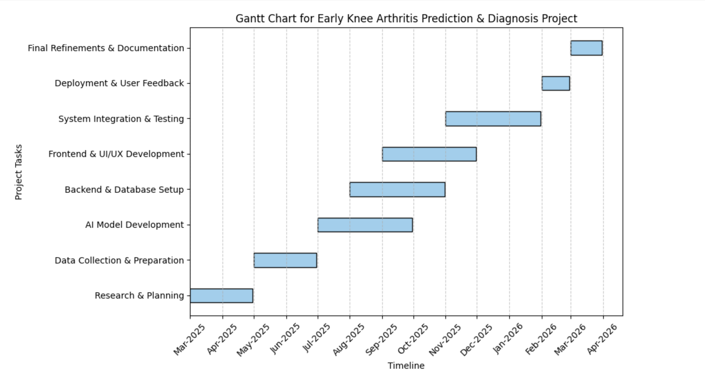

14. Future Enhancements:
- Telemedicine Expansion: Integrating video consultations for remote patient assessments.
- AI-Powered Virtual Assistants: Implementing chatbot-based health guidance for patients.
- Real-Time Pain Monitoring: Using AI-driven sentiment analysis on patient feedback to assess pain levels dynamically.
- Expanded Research Integration: Collaborating with hospitals for larger datasets to improve AI accuracy.
- ML-Based Recommendation Engine (Optional/Advanced): Beyond rule-based, train a simple decision tree or XGBoost model using input features like KL Grade, Age, BMI, Activity Level, and output labels like recommended steps, calories, risk level, trained on a synthetic dataset.

Mockups:
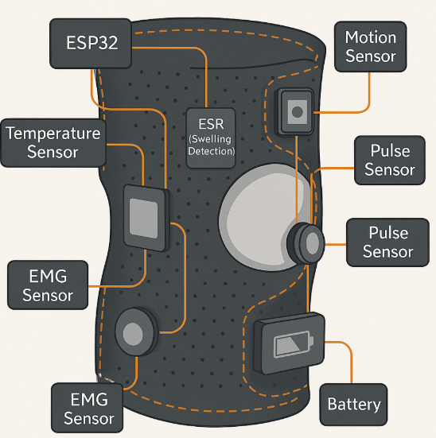
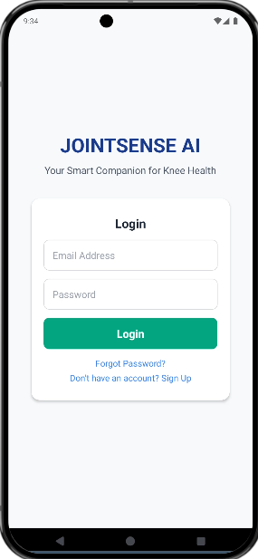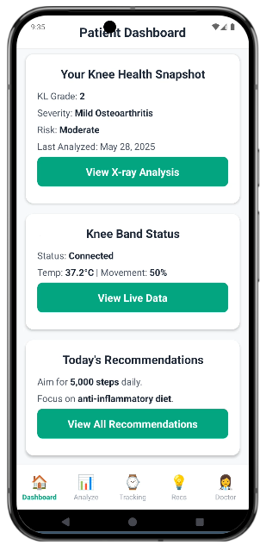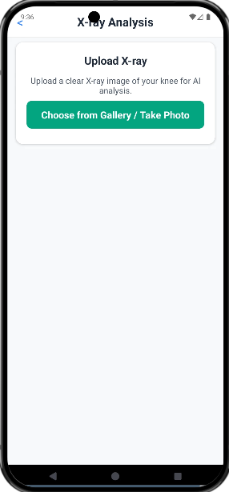
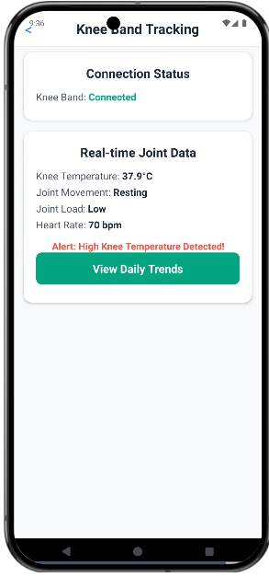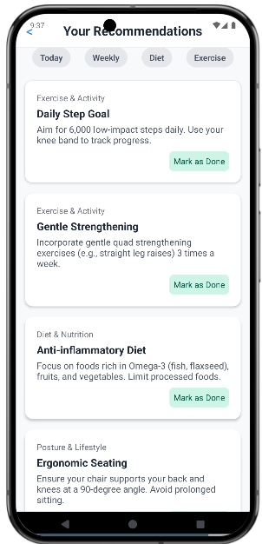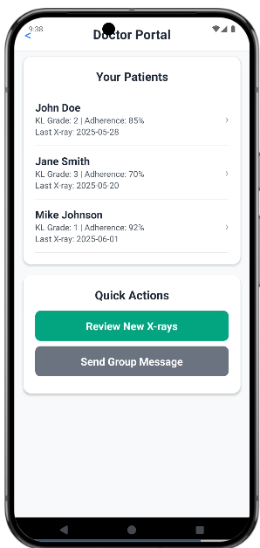

Login Page:

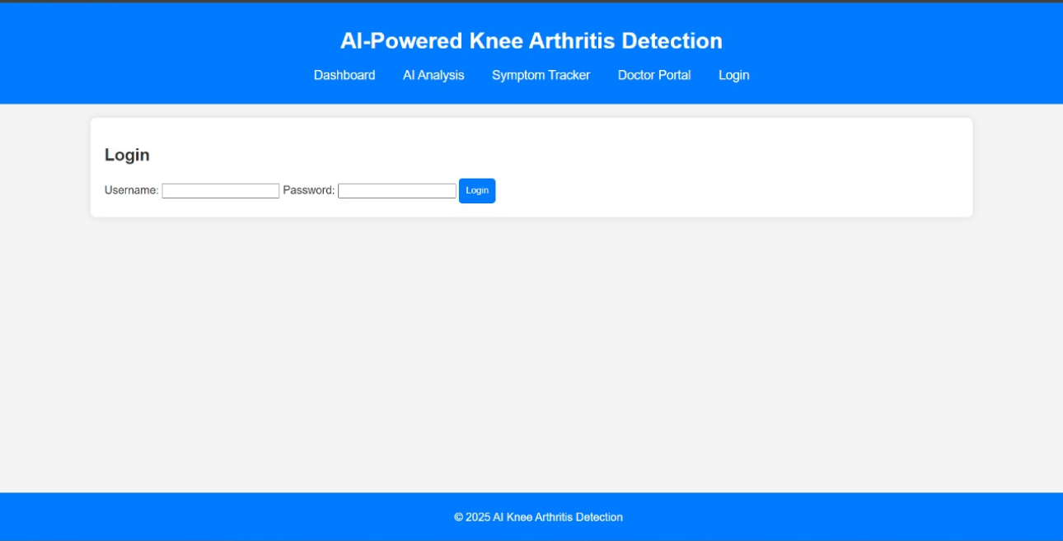

Dashboard Page:

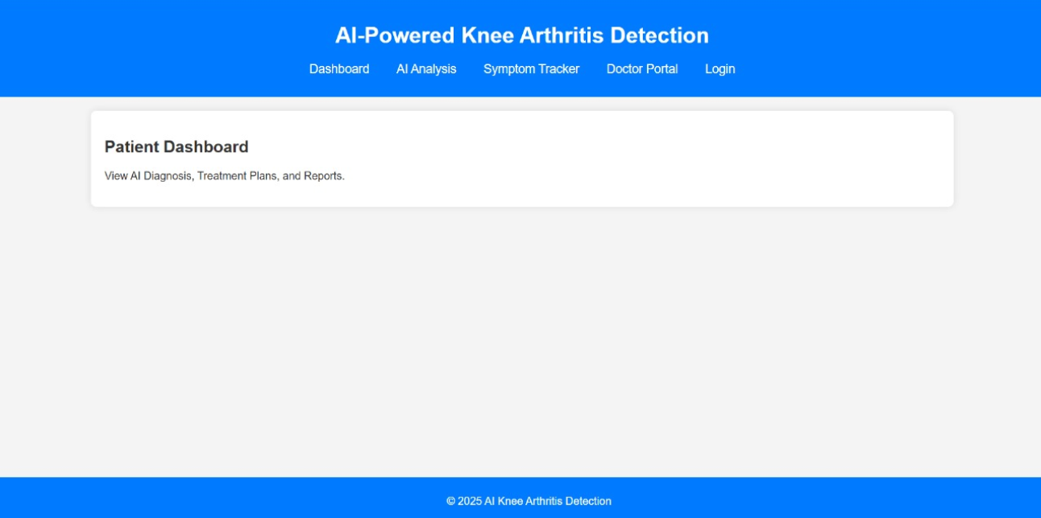

AI Analysis:

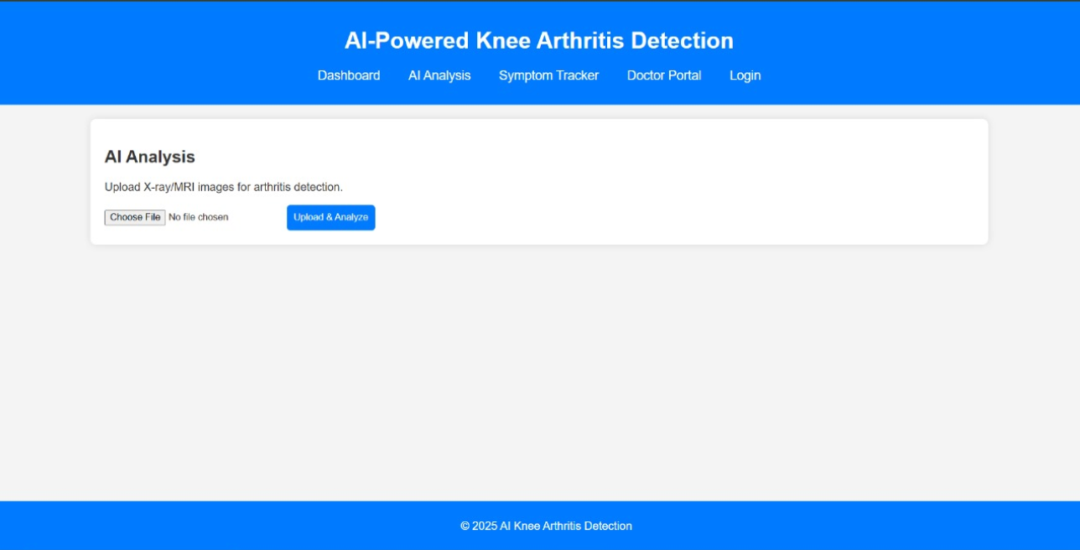

Symptom Tracker Page:

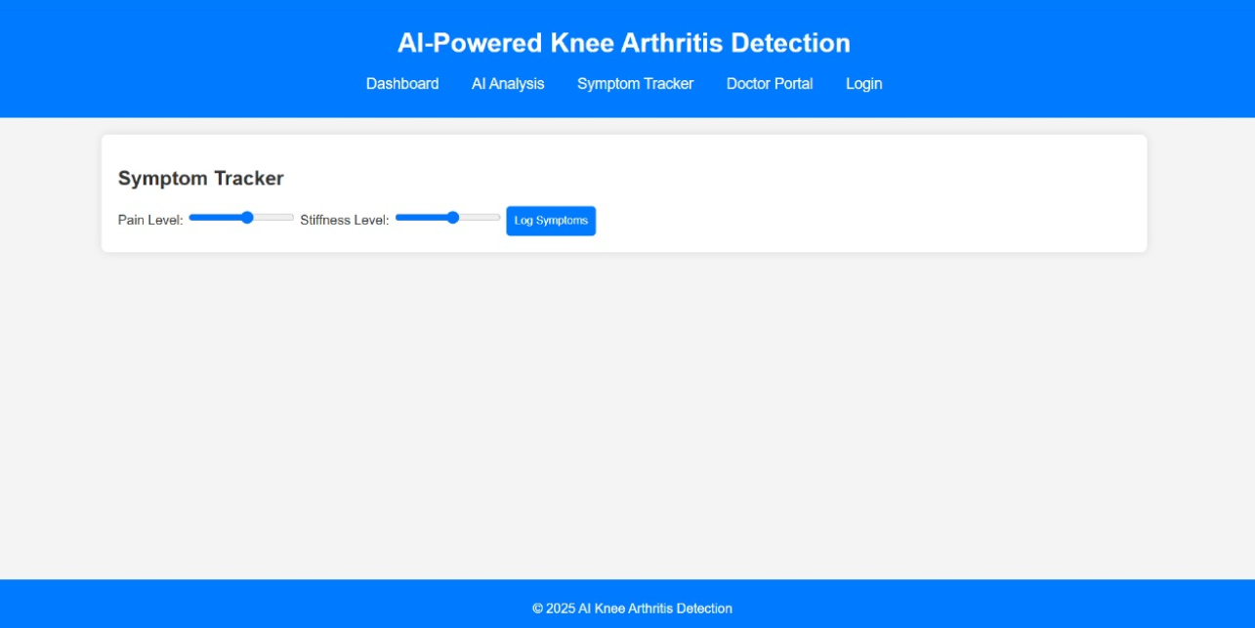

Doctor Portal Page:

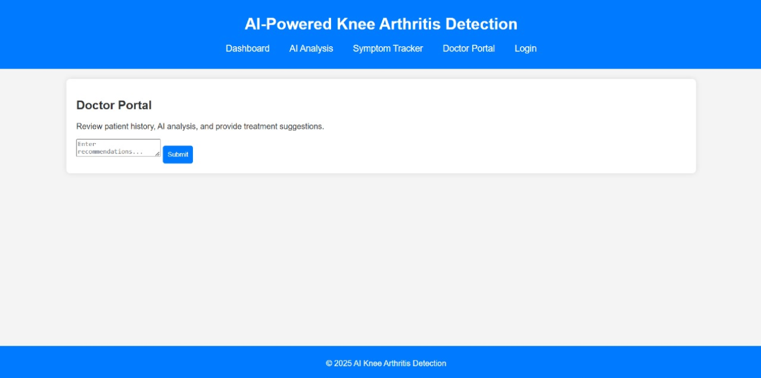

Conclusion:
This project presents an AI-powered knee osteoarthritis prediction and severity grading system tailored to enhance early prediction, personalized lifestyle management, and real-time adherence tracking. By integrating AI with medical imaging (X-rays) and leveraging IoT and mobile sensor data, the platform offers an innovative, accessible, and efficient approach to OA management, ultimately aiming to improve healthcare outcomes through proactive intervention and continuous feedback.

